School of Engineering

Integrated Design Project 2 Detail Design

2019/20

Group: E7

E7 Vertical Farm

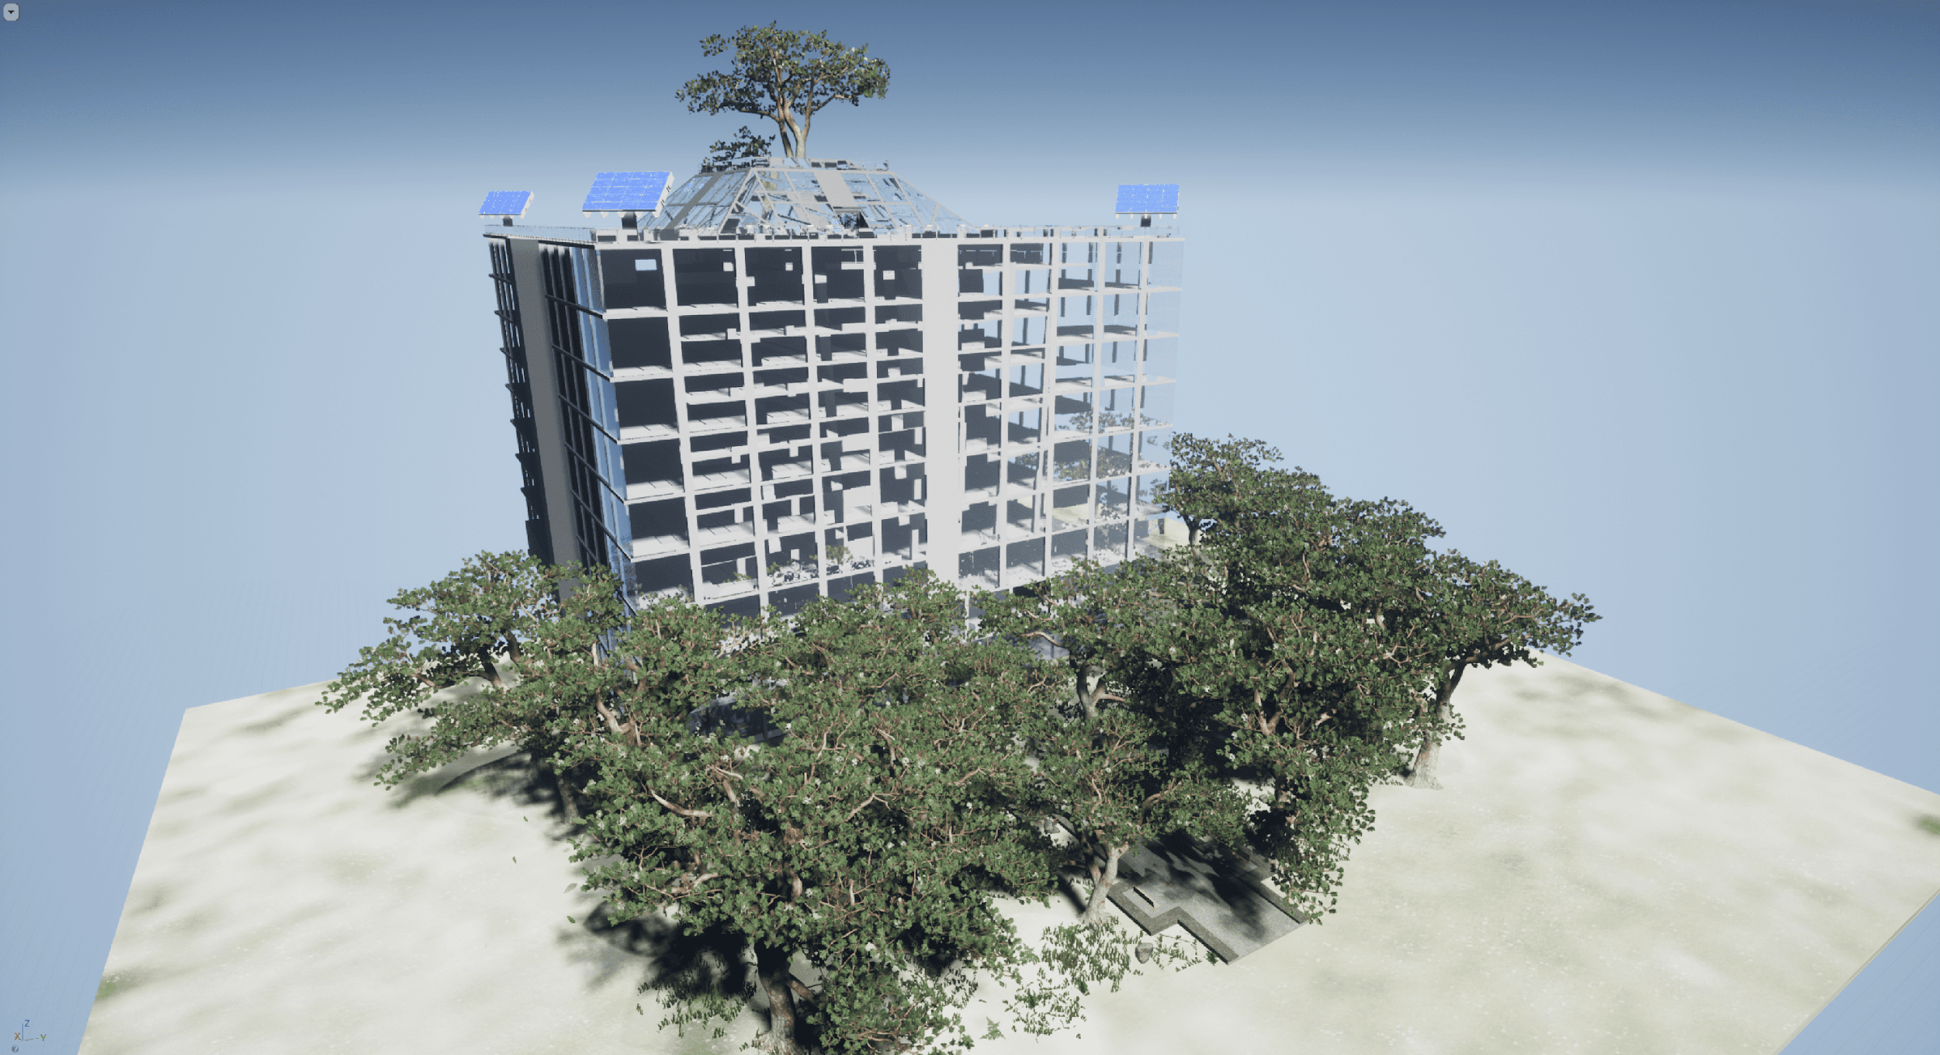

Date: 27th March 2020

Authors

Callum Jones ID: 1926388

William Lubiantoro ID: 1891452

Chun Chow ID: 1986443

Tao Hu ID: 1879827

Antonio do Valle Pombal ID: 1947247

James Hewer ID:

# Statement of Contribution

|  |  |  |  |
| --- | --- | --- | --- |
| Name | Student ID | Contribution in their own words | Contribution level agreed with the group with respect to the group average.  (high/normal/low/none) |
| Callum Jones | 1926388 | Group Coordinator  Created the luminosity system and wrote up the concept design and concept design model sections. | High |
| William Lubiantoro | 1891452 | Created Temperature system. Designed and created VR model in Unreal Engines and all the CAD. | High |
| Chun Chow | 1986443 | Created the humidity system. | High |
| Tao Hu | 1879827 | Created the CO2 system. | High |
| Antonio do Valle Pombal | 1947247 | Created the Façade/Roof subsystem | High |
| James Hewer |  |  |  |

# Concept Design

When starting this project, the designs from semester one, from each team member, were displayed side-by-side. Each member then stated key points and features of their farm with the greatest emphasis on the following areas: generation and supply of power; functionality of the moving façade and environment control systems (lighting and humidity for example). The aesthetics of the design were also considered but had little effect on the overall decision.

Among all the designs, there were numerous similarities within the key areas. The main similarity was the use of solar panels to generate electricity for the farm. This idea became a vital section of concept design and would allow us to meet the energy demands of the farm in a renewable technique. The use of renewable energy sources was a key factor in the decision of which concepts should be used. This is because this would allow the vertical farm to meet numerous UN Sustainable Development Goals (goals 7 and 13). As this was a major similarity between designs, the use of solar panels was implemented into our overall concept with the addition of a connection to the electrical grid. This is clear any energy deficit that may occur.

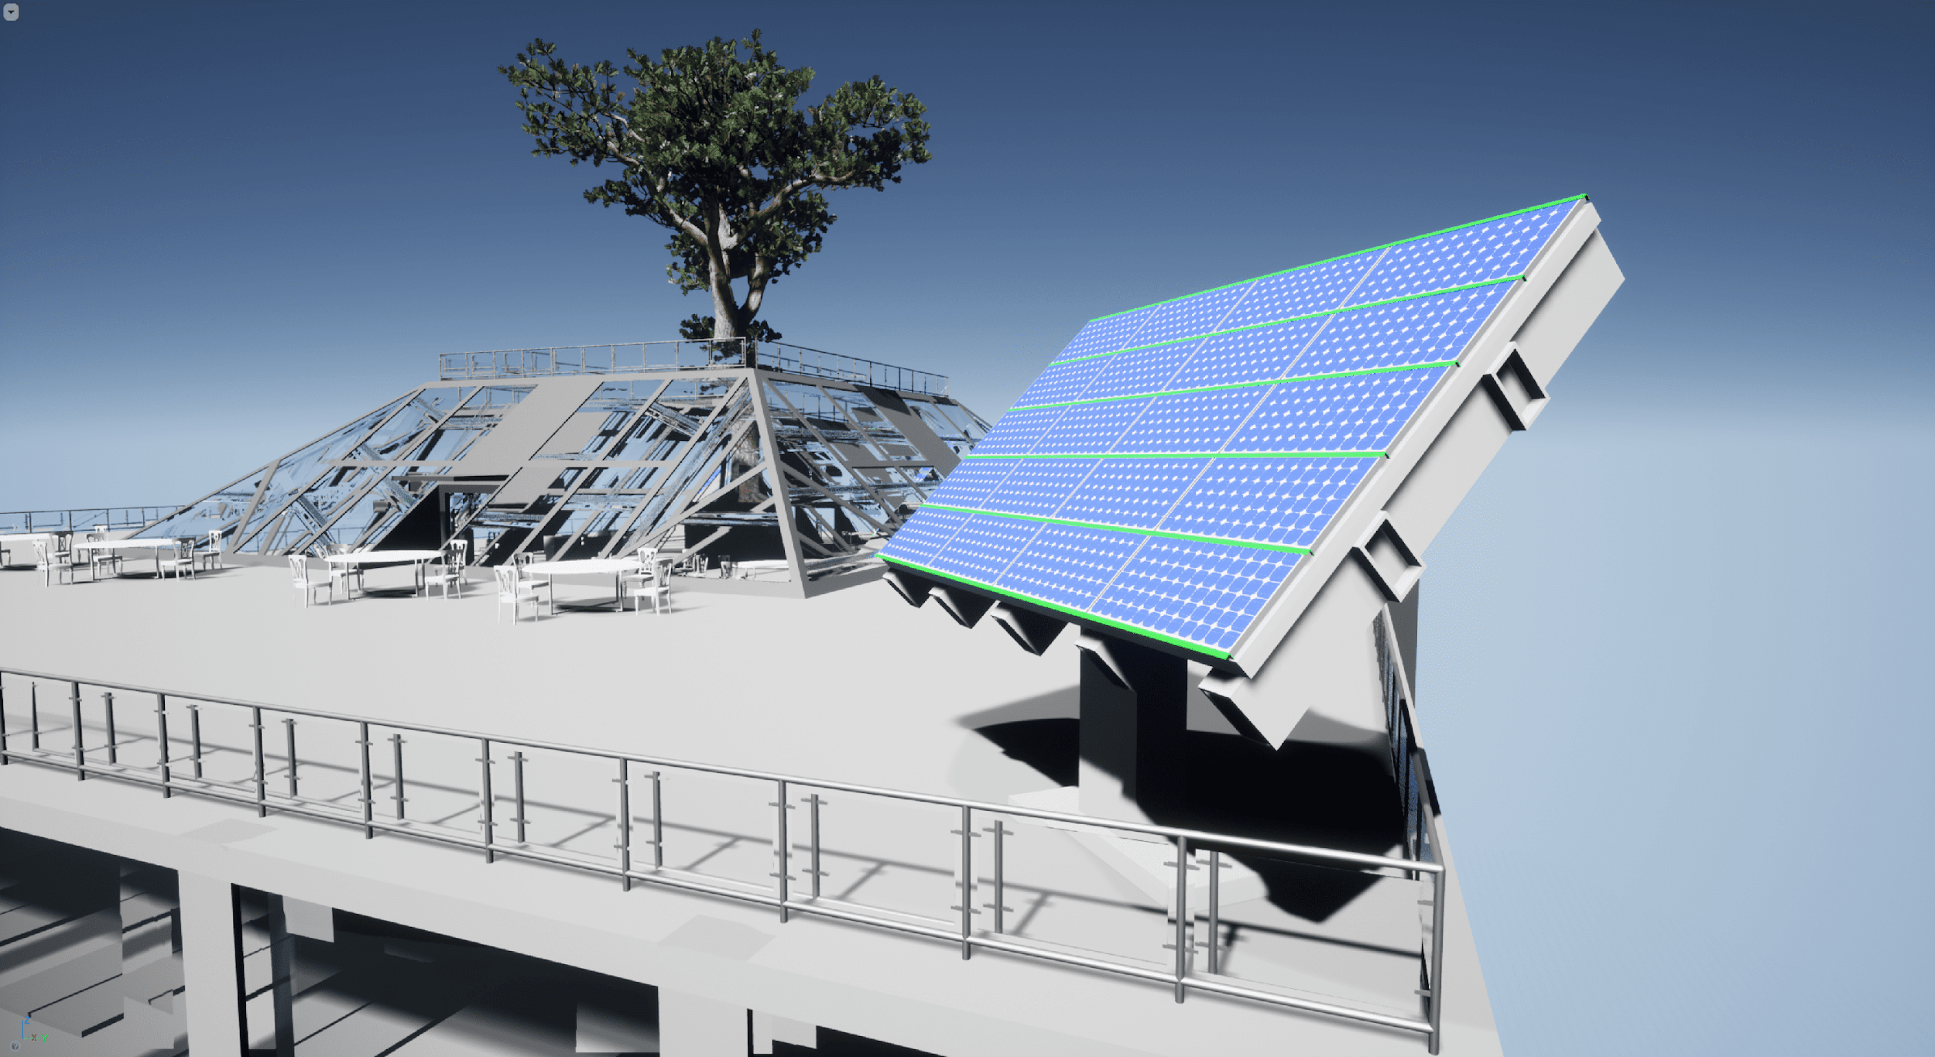The purpose of the moveable façade in our design was to maximise sunlight exposure on the solar panels. To do this, the solar panels will be the moveable objects of the façade. They will change their direction in order to match the pathway of the sun, maximising light exposure. This will ensure that they are producing the maximum possible energy. *Figure 2* shows the use of moveable solar panels.

**Figure 1. Rooftop and Solar Panel inside VR model**

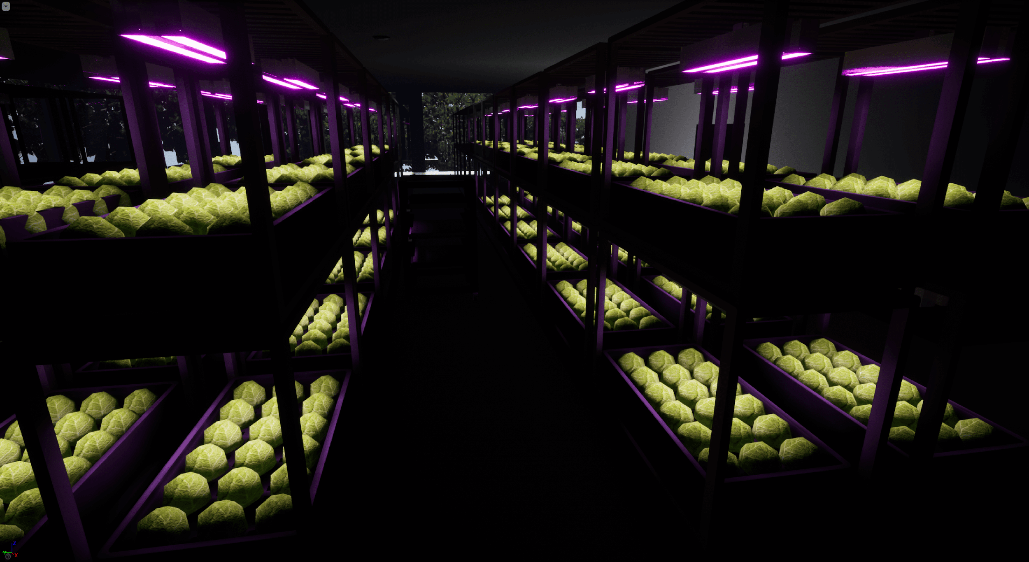The concepts from semester 1 had numerous different purposes of the moving façade. We agreed that the façade should try and maximise the energy input to the farm while requiring a small amount of energy to operate.

The shape of the building allows for a large cropping growing space to have the yield of the farm as large as possible. This will help the farm to meet Sustainable Development Goal 2. The crops are grown in culture rooms. The environment within these culture rooms will be maintained to set conditions. The systems that control the environment are detailed further into the report. *Figure 3* shows a section of a culture room and the arrangement used to grow the crops.

**Figure 2. Culture Room inside VR model**

**Figure 3. Section of culture room**

# CONCEPT DESIGN Model

Once the features of the concept design had been decided, we discussed how we were going to create the model. We decided that a virtual model should be made, and virtual reality features should be implemented to showcase the model. To achieve this, we decided a game engine should be used to create the virtual environment.

To produce the model, the existing Solidworks drawing of the vertical farm, from semester 1, was used. We initially started by using Unity. However, in order to import the Solidworks drawing into this engine, a mesh of the drawing had to be created. We used a program called MeshLab to produce the required mesh. However, when the model was imported into the game engine, we found that the Unreal engine offers more accessible VR creation tools and the lead of task 1 felt more comfortable using this engine. The Unreal engine didn’t require a mesh of the Solidworks drawing to be produced. Instead, a plugin called ‘datasmith’ was used allowing the direct importation of Solidworks parts and assemblies.

Once the building asset was in the engine, additional assets could be inserted. The growing shelves, rooftops and doors were imported from Solidworks drawings with the remaining assets being from the Unreal asset store. These assets were free to use and are built into the engine.

The virtual reality functionality of the model was never completely tested due to team members returning home meaning equipment wasn’t available to use (highlighted in appendix). However, a playable character can be controlled allowing the audience to walk around the farm.

The aim of this model was to offer an interactive presentation of our concept design. This would allow the audience to walk around the farm in a virtual space allowing them to get the best perspective possible due to the immersive nature of virtual reality. The interactive nature of the model such as interactable doors and elevators would help to keep the audience engaged and make our concept stand out.

The final result of the model provides a clear perspective of the concept design. The culture rooms show an accurate representation of the configuration and capacity of the growing space. Furthermore, the environmental control has been touched upon within the model with the inclusion of the lighting system. These systems will be explored within the rest of the report.

# Detail Design Summary

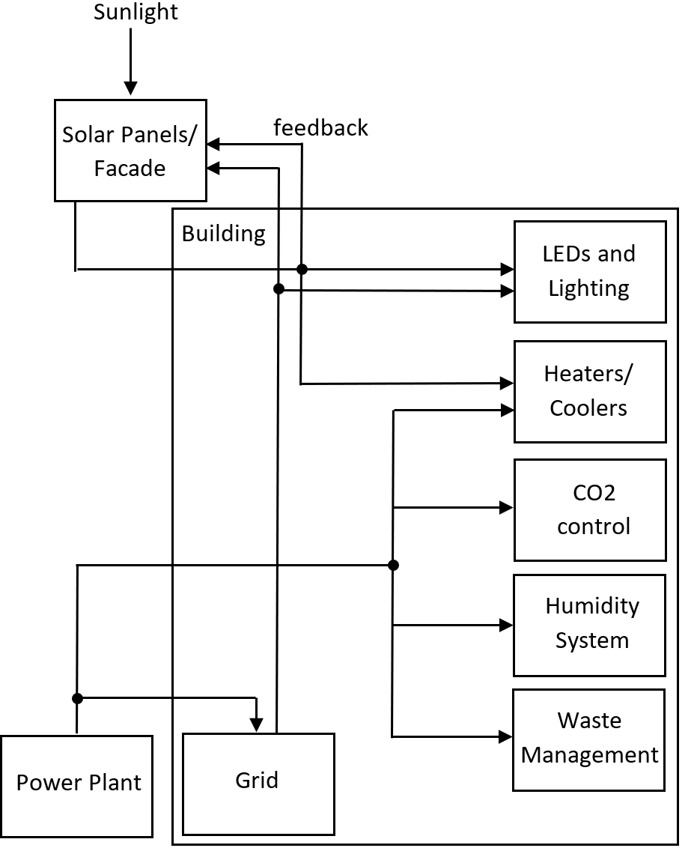

**Figure 3. Schematic of how each sub-system generates their power**

Figure 3 shows how each of the subsystems in this vertical farm generates its power. Subsystems like temperature control and LEDs make use of power generated by solar panels in order to decrease the amount of electricity usage throughout the entire building as these use the most power. But solar panels can only provide enough, so in the case of deficit energy, power from the grid or the power plant will be used. The LEDs make use of the power from the grid in the form of a three phase voltage source whereas every other system utilizes AC voltage taken directly from the power plant as that is how most of the devices and electronics work. Additionally, the solar panels will provide energy to face itself towards the sun to minimize the usage of electricity.

# Luminosity Subsystem

## Qualitative Description:

The luminosity system is used to ensure that a constant light level is maintained within the culture rooms. In order to do this, an open loop control system must be implemented to sense current light levels in the environment. Furthermore, the load needs to be enhanced from a single resistor in order to measure these light values and to try and obtain a more efficient system (LEDs due to minimal heat losses). Finally, the power delivery must be stable. This means that renewable sources will have to have back-up energy sources to clear any energy deficit.

## Quantitative Description: Specification Table

To produce the model, there are numerous specifications that must be fulfilled.

|  |  |
| --- | --- |
| Component | Specification |
| Grid Connection | Three-phase AC source at a frequency of 50 Hz. The rms voltage must also be rated at 415 V. |
| Transformer | Three-phase transformer with a primary coil voltage of 415 V and secondary coil voltage of 100 V. |
| PV Array | Irradiance to be at 1000 W/m2 (average) and potentially decrease. |
| Diode-Bridge Rectifier | Consists of 6 diodes |
| Power Switches | To be closed when the voltage across the PV array becomes less than 150 V. |
| Load Switch | Closed when inside light intensity is less than 800 W/m2. |

## Model: The Simulation model diagram(s)

### Overall Model

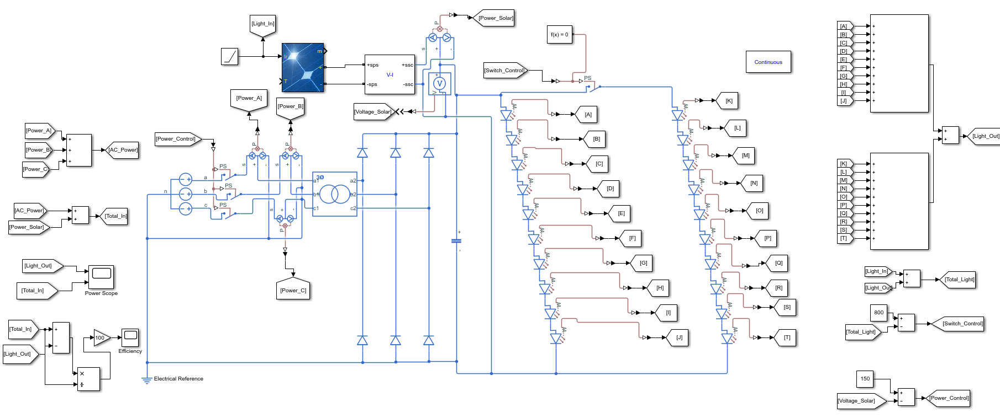Figure 4 demonstrates the overall model for the lighting system. The model only consists of 20 LEDs which equates to 5 growing shelves. A full-scale model couldn’t be produced as this would be too complex and would take a very long time to run the simulation.

**Figure 4. Simulink model representing the lighting system**

### Power Generation

The generation of power is primarily conducted by solar panels (PV array). However, the power these generate will vary throughout the day so an additional connection to the grid is required. This is modelled using a three-phase voltage source configured to 415 V and 50 Hz. A three-phase source was used as this provides a high-power connection to the grid and represents the likely connection the facility would get if constructed. The grid connection will only be used to eliminate a potential deficit in energy. This enhances on just using a DC source as more sophisticated power conversion is required.

**Figure 5. PV array**

### Power Conversion

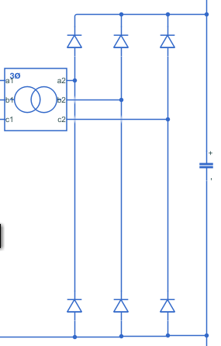A transformer is used on the three-phase power supply to step-down the voltage. This conversion enhances on the potential divider as the transformer offers a more efficient way of reducing the voltage. Furthermore, a potential divider outputs wasted energy as heat which could increase the strain on the temperature control system. The stepped-down AC signals are then inputted into a full-wave diode-bridge rectifier. This converts the AC input to DC which is required to power the load. The power generated by the PV array is already in DC, therefore requires no conversion.

**Figure 6. AC power generation**

**Figure 7. AC three-phase transformer and diode-bridge rectifier**

### Load

The load of this subsystem are the light-emitting diodes. The use of these enhances the simulation as values for light energy emitted from each LED can be obtained via the Simulink domain (not possible using just a resistor). These values can then be used within the control loops and efficiency calculations. Furthermore, the load of the circuit can vary depending on the conditions of the control loop (highlighted in the next section). This means that the load can be halved by reducing the number of LEDs that are active.

**Figure 8. Twenty LEDs with control switch**

### Control

There are two control systems within this system. The first control system enables power input from the AC source (grid). This involves the use of switches that close once the voltage across the PV array is less than 150. In order to achieve this, a subtraction node was used as the switches are close when the input is greater than zero. The second system is used to turn off half of the LEDs. This is used to control the light levels in the culture rooms. The light levels are measured and control a switch connected to the LEDs.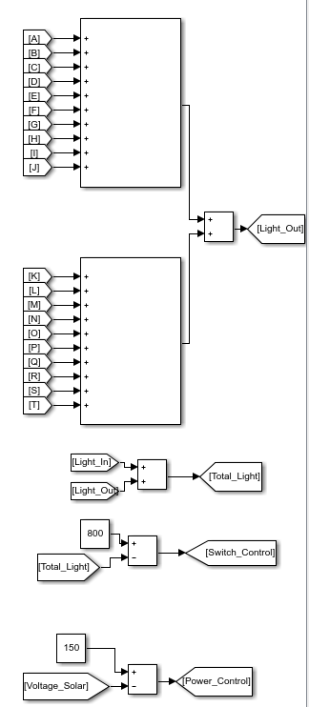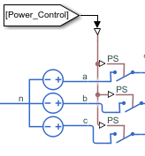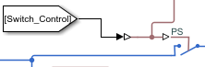

**Figure 9. Lighting control system in Simulink domain**

**Figure 10. Control switch grid connection.**

**Figure 11. Control switch for variable load.**

## Analysis: The Simulation Result

### Inputs and Outputs

The main inputs to this system are sourced from the PV array and the three-phase source. When the voltage across the PV array becomes less than 150 V, the three-phase source inputs at 415 V at 50 Hz. For the simulation, we assumed that all the power was being produced by the PV array (running in optimal conditions). To model the light irradiance, a ramp was used to simulate a slowly reducing light intensity. This started at 1000 W/m2 (average light intensity in the UK). The main output of the system is the light power emitted from the LEDs.

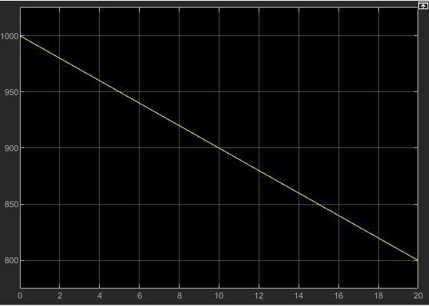

**Figure 12. Ramp used to simulate outside light intensity.**

### Energy Efficiency

As the simulation only contained a very small portion of the overall load of the farm, the values obtained for useful power out and efficient are much less than they would be. Figure 13 represents the power in and power out with figure 14 showing the efficiency of this simulation.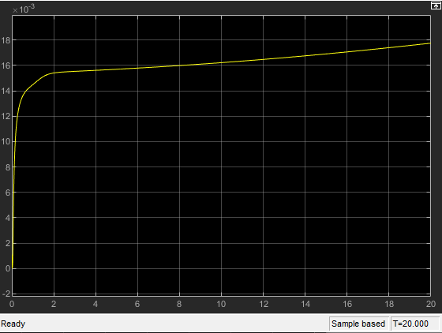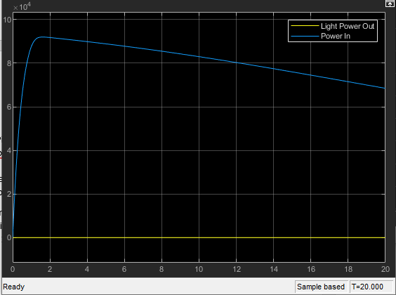

**Figure 14. System Efficiency**

**Figure 13. Input and Output power comparison**

**Figure 13. Power scope**

**Figure 14. Efficiency scope**

The true efficiency would be much greater due to the load being larger resulting in more optical power being outputted. Furthermore, the power left available can be used by other systems. An improvement to the simulation could be to add power restoration.

# Temperature Subsystem

## Qualitative Description:

This temperature control system ensures a stable automatic temperature control over the growing rooms at around 16 degrees Celsius. The thermal subsystem in the provided model measures the room temperatures and compares it to a set temperature and uses the error between them to adjust the thermistor that acts as the heater or load. The heater/ load receives power from an AC voltage source that was rectified and smoothed by a capacitor filter. The AC source that powers the heater comes from the power plant that powers the building.

## Quantitative Description: Specification Table

|  |  |
| --- | --- |
| Component | Specification |
| AC Source | Single-phase AC source at a frequency of 50 Hz at 220V. |
| Transformer | Ideal transformer with 14 Winding Ratio (Primary to Secondary) |
| Rectifier | 4 Diodes to convert AC-DC |
| Thermistor | Load that changes depending present and past value of temperature |
| Operating Temperature | 16 degrees Celsius |

## Model

### Overall Model

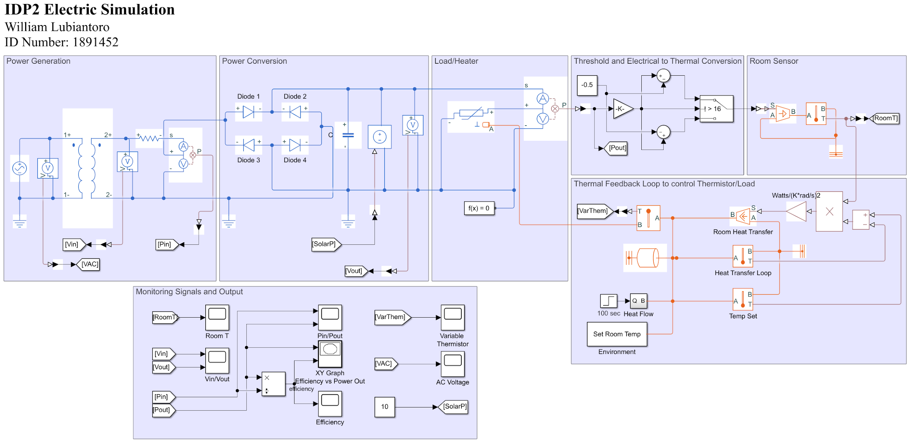

**Figure 15. Simulink model of the temperature control system**

### Power Generation

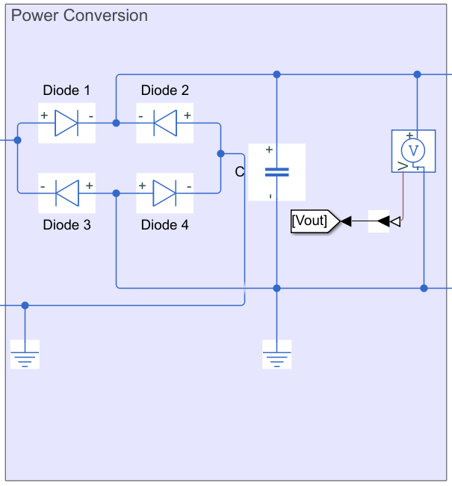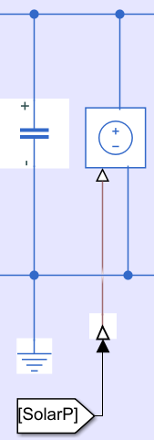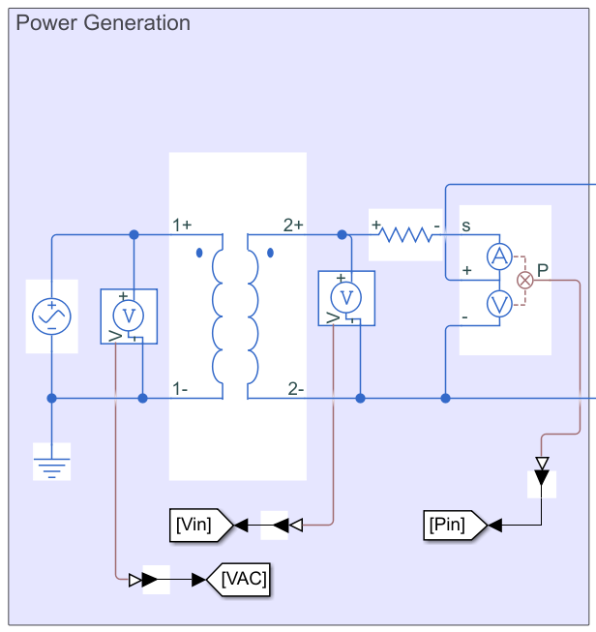Power is generated through an AC voltage source as the building receives its power from the power plant, instead of the grid. A little bit of the power also comes from the solar panels which is represented by the controlled voltage source but because the solar panels cannot supply the temperature system indefinitely, it needs more power from the outside. This model uses an AC voltage source of 220V at 50Hz and is passed through a transformer and resistor. The transformer is responsible for increasing the AC voltage while the 1.25k Ohm resistor limits the amount of current passing through so that the power that is supplied to the thermistor is not a sudden instantaneous increase but a slower and gradual increase, just like how a heater would need to power up.

**Figure 16. Power Generated from AC source**

### Power Conversion

The rectifier in this part of the model converts AC voltage to DC voltage by using 4 diodes and the capacitor at the end smoothens the output so it becomes more stable and less random.

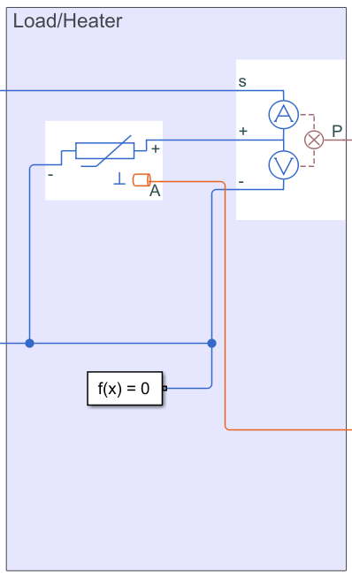

**Figure 17. Converting AC-DC using rectifier**

### Load

The load in this system is represented by a thermistor that changes when the measured temperature in the room changes. This thermistor has the same functions as that of a variable resistor in that if a current passes through it, it generates heat in terms of power dissipating. The amount of power dissipation is measured and converted to temperature.

**Figure 18. Thermistor representing the heater as a load**

### Control

The control system takes the room temperature and feeds it back through a thermal domain that compares the present room temperature to an already set room temperature. When the room temperature is above 16 degrees, it will increase the value of the thermistor because the room needs to be cooled, and vice versa. The other parts of the thermal domain measures the temperature at certain points so that the error between the room temperature and the set temperature can be calculated and then taken into account to change the resistance of the thermistor due to temperature change.

**Figure 19. Thermal Feedback, using thresholds and set point**

## Analysis: The Simulation Result

Figure 20 shows how the Room Temperature changes over time. The target temperature in the thermal domain was set to 16, so after some time the temperature of the room will settle at the target temperature due to the thresholds. The thick output waveform shows that the room temperature is fluctuating up and down constantly, but under a safety margin. Too high above 16 and the output will go down, too low and the output will go up. Therefore, a stable and constant average temperature was generated as they are the specification needed for the crops to grow efficiently. However, connecting the power generation section with a controlled voltage source that acts as power from the solar panels messes up the results, so it was commented out in the model. 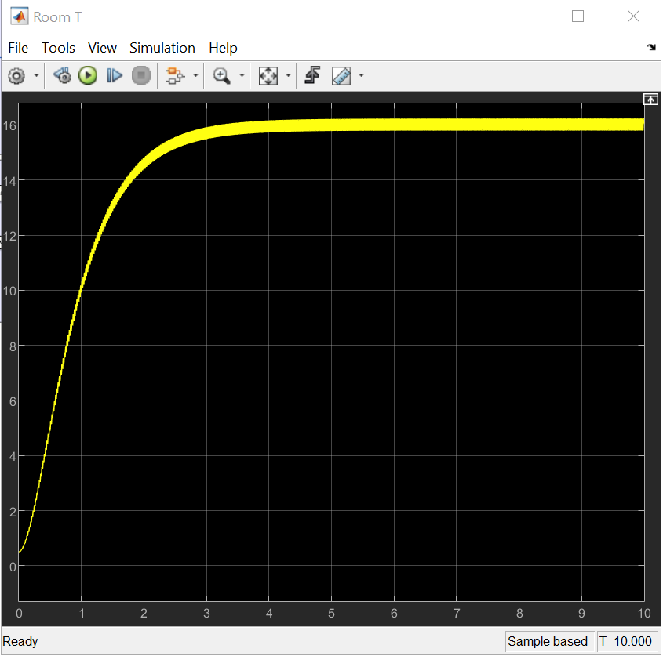

**Figure 20. Room Temperature over time**

Inputs and Outputs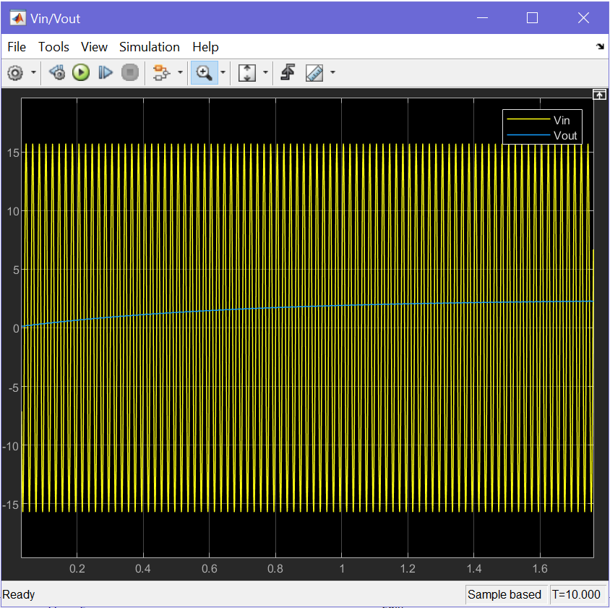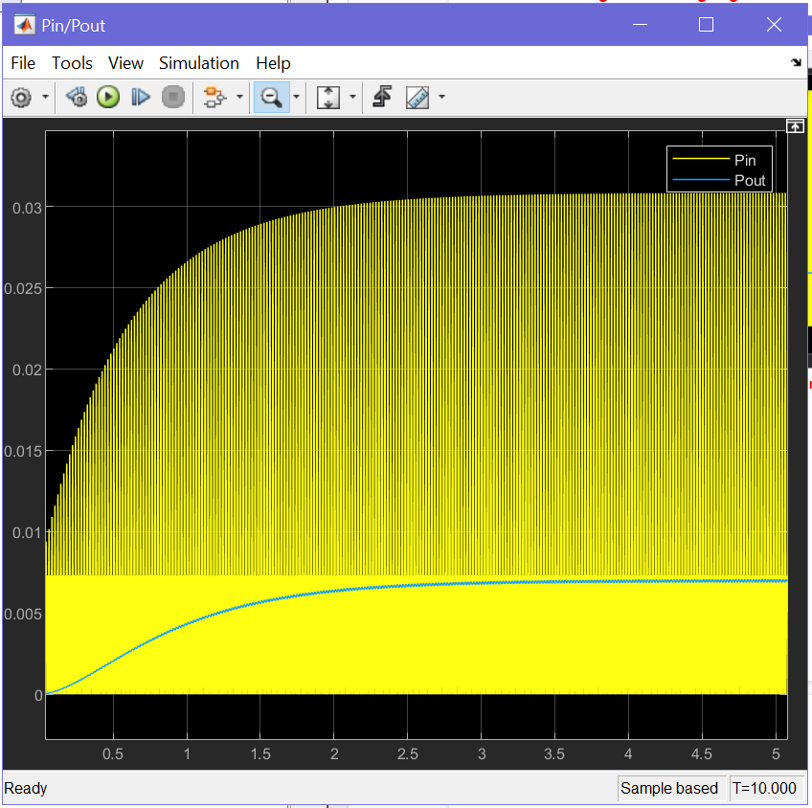

**Figure 21. Voltage signals before and after the rectifier Figure 22. Comparison of Power In and Power Out**

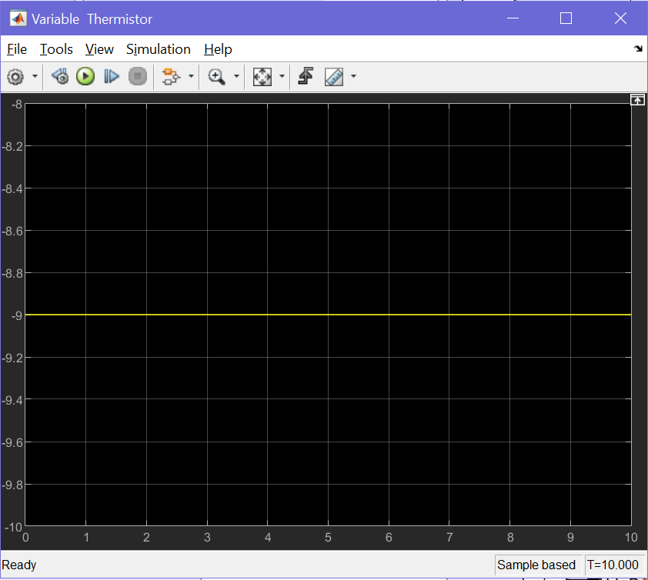Figure 21 shows a 220V AC voltage at 50Hz was used as the power source to supply the heater. It was then rectified to get a steady increasing positive signal. The gradual increase in output voltage was due to there being a resistor before the rectifier so that the slope won’t be too steep and the amount of current going into the thermistor can be controlled. But this created problems in that the total output voltage is much lower than expected. Figure 22 shows the Power In signal oscillating back and forth due to the AC voltage input and the resistor that is limiting the amount of current that can pass. This generated a signal that is higher than the output and an area underneath it, which is incorrect. While the Power Out signal is much smaller compared to the Power In signal it is much cleaner and stable so that the heater does not get any malfunctions or any sort of electricity shut-downs. But evidently, both Figures 21 and 22 are wrong.

### Figure 23 should display how the temperature in the thermistor changes but evidently this shows that the thermal feedback is not working correctly and that the thermistor is completely relying on the input voltages from the AC voltage source and the rectifier. This goes to show that there is a lot that needs to be improved in the model even though the final results look great and legitimate.

### 

### 

**Figure 23. Temperature sensor on the Thermistor**

### Energy Efficiency

Because the signals for the Pout and Pin were incorrect and reliable, it also affects the efficiency and the XY graph. For an efficiency graph it does not make sense as it only outputs a square wave which means that it's only positive at some intervals.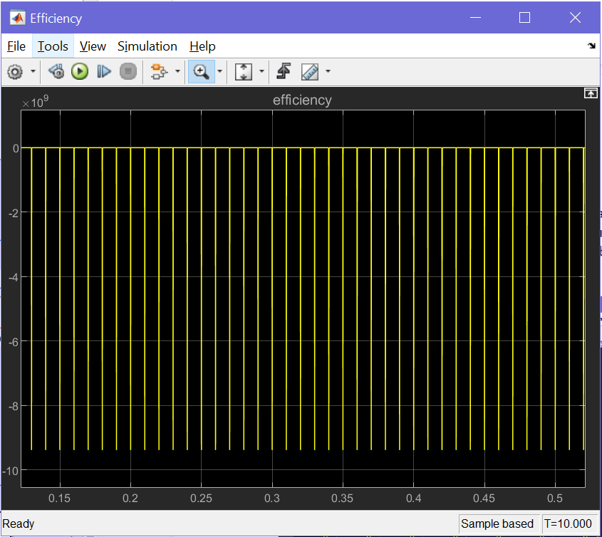

Additionally, lots of improvements can be made to the whole model. A switch case or PID controller can be implemented to make an easier feedback loop that works.

**Figure 24. Energy Efficiency**

# Humidity Subsystem

# Qualitative Description:

The humidity system is designed to monitor and control the humidity of the indoor farm with humidity sensors. Thus, a closed loop control system will be established to compare the relative humidity level with our targeted indoor humidity level (50%~60%), to maintain a stable indoor humidity level. Besides, the system depends on the temperature and CO2 systems as thermal and trace gas data are required. Energy efficiency is also considered, renewable energy (solar power) is used while with the main grid as a secondary power source. In order to maximize the farm’s sustainability.

## Quantitative Description: Specification Table

|  |  |
| --- | --- |
| **Component** | **Specification** |
| Power Source | 220 V (single-phase AC at 50 Hz |
| Transformer | Ideal transformer (wing ratio primary/secondary = 14) |
| Rectifier | Transform AC/DC with 4 diodes |
| Relative Humidity | (50~60) % |
| DC motor | Electrical energy is used to drive the load (air extraction and misting system) |
| Inertia | To ensure the operation of the rotational converter |

## Model: The Simulation model diagram(s)

### Overall Model

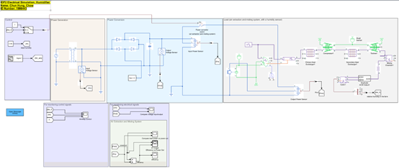

**Figure 25. Simulink model of the Humidity Subsystem**

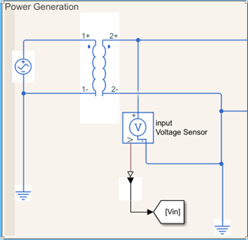

### Power Generation

Main grid is the main power supply to the farm, so the main grid is put into power generation. Thus, an AC voltage source is used to represent the power source (main grid), which is set to be 220 V at 50 Hz. Although solar power is our ideal power source, only the main grid is considered in this model as it provides a stable supply. Besides, the AC voltage at 220 V is transformed and stepped down by a ratio of 14.

**Figure 26. Humidity System – Power Generation Node**

### 

### Power Conversion

As the power supply from the main grid is an AC voltage, it is rectified by 4 diodes after it is transformed. Thus, it matches to supply DC voltage towards the load (air extraction and misting system, humidity sensors). Besides, a capacitor is added to smooth the dc voltage.

**Figure 27. Humidity System – Power Conversion Node**

### Load

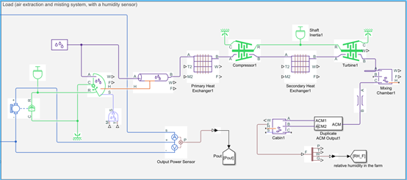The load is based on an example of an aircraft HVAC system. Thus, both air extraction and misting systems are the same load. The electric energy is driven to the load by the dc motor towards the rotational mechanical converter to control the turbine. Besides, high and low signals are sent to a switch in the power conversion section which tell the load to function when the humidity level is not in the targeted range.

**Figure 28. Humidity System – Load**

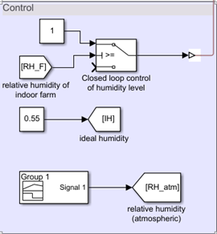

### Control

In this section, a closed loop control system is designed as the relative humidity level has to be monitored and controlled. A targeted range (50%~60%) relative humidity level is set as it is most beneficial to plant growth. Thus, when the humidity level is below the range, misting system will function to increase the humidity. In contrast, the air extraction system will work when the humidity level is above the range.

**Figure 29. Humidity System – Control Node**

## 

**Figure 30. Humidity System – Outputs, Inputs and Comparison**

## Analysis: The Simulation Result

### Voltage Inputs and Outputs

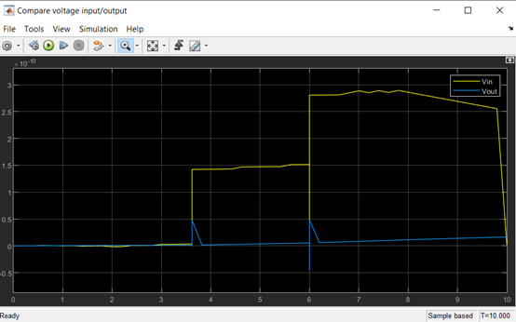The input voltage should be an AC voltage. As it is measured after being transformed, the Vin should be a sine wave with peak amplitude around 15 V at 50 Hz. However, the analysis failed to show. While the Vout is rectified with 4 diodes and smoothened by a capacitor and becomes a DC voltage.

**Figure 31. Humidity System – Voltage output and input from simulation results**

### Power Inputs and Outputs

**Figure 32. Humidity System – Power output and input from simulation results**

### Energy Efficiency

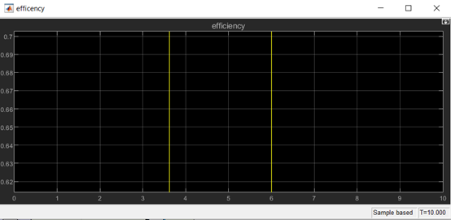The relative humidity level in the farm is monitored by humidity and trace gas sensor.

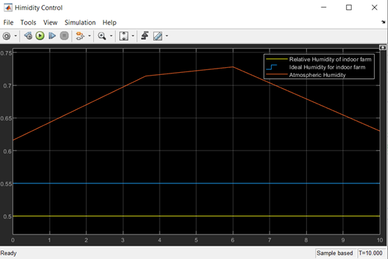

**Figure 34. Humidity System – Humidity level comparison**

**Figure 33. Humidity System – Energy Efficiency**

Co2 Subsystem

## Qualitative Description:

The CO2 system simscape model includes the power source, converter and model the load for the CO2 control system. It can monitor and control of CO2 Acquire (sense) C02 level to adjust growth speed to market demands. The level will be controlled at 1000 ppm (parts per million). The DC motor received voltage source that was rectified and smoothed by a LC filter. The fan for ventilation will be driven by the DC motor

## Quantitative Description: Specification Table

|  |  |
| --- | --- |
| **Component** | **Specification** |
| AC Source | Single-phase AC source at a frequency of 50 Hz at 220V. |
| Transformer | Ideal transformer with 14 Winding Ratio (Primary to Secondary) |
| Rectifier | 4 Diodes to convert AC-DC |
| DC motor | For driving the ventilator |
| Fan inertia | to ensure the operation of indoor ventilation |
| Load Switch | close when inside ppm is within the range (975-1025). |

## Model: The Simulation model diagram(s)

### Overall Model

**Figure 35. Simulink Model of the CO2 control system**

### Power Generation

Power is generated through an AC voltage source as the building receives its power from the power plant, instead of the grid or the solar panels. This model uses an AC voltage source of 220V at 50Hz and is passed through a transformer.

**Figure 36. CO2 System – Power Generation Node**

### Power Conversion

The rectifier in this part of the model converts AC voltage to DC voltage by using 4 diodes and the capacitor at the end smoothens the output so it becomes more stable and less random.

**Figure 37. CO2 System – Power Conversion Node**

### Load

The load is the DC motor that received a rectified and smoothed voltage source. The fan for ventilation will be driven by the DC motor. The DC motor will be controlled by the load switch when the ppm dectected by CO2 sensor is out of range. The ventilator will extractor the extra CO2.

**Figure 38. CO2 System – Load**

### Control

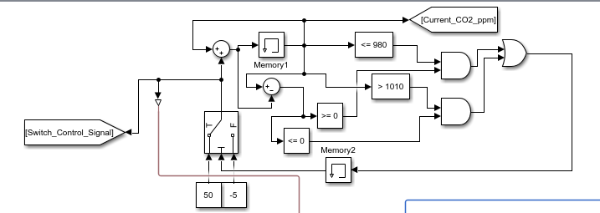The control part is connected to the load switch. It will keep the ppm of the concentration of CO2 with the range of 975-1025 for the plant growth, which will make the plants best for demand market.

**Figure 39. CO2 System – Control Node**

## Analysis: The Simulation Result

The range of the output ppm can be verified by the figure below. As it can be seen, the target range of ppm is set to be the value between 975-1025.

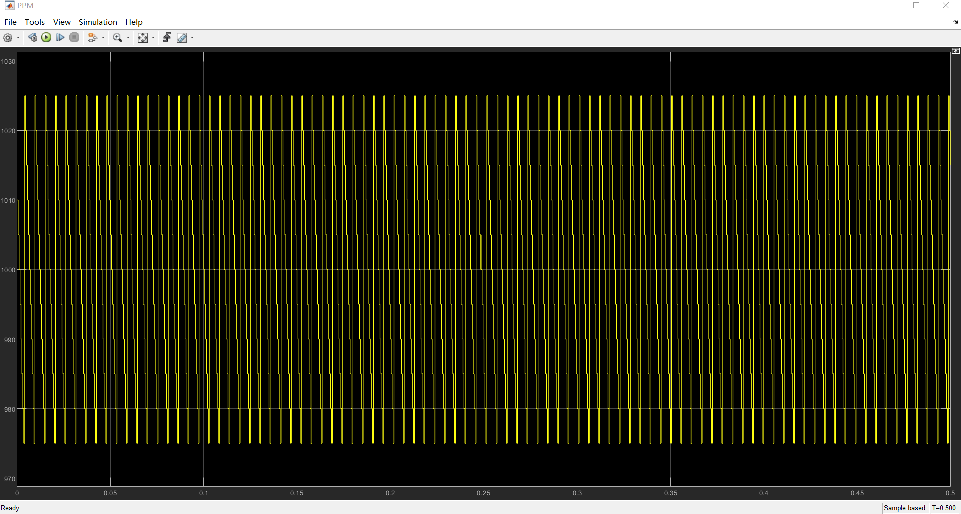

**Figure 40. CO2 System – CO2 levels from simulation**

### Inputs and Outputs

The input signal is AC voltage. After the bridge rectifier, it will change to DC voltage. Also, by adding a capacitor filter, the DC voltage signal will be more stable. The second picture below shows the comparison between the input voltage and output voltage. Due to the fact that the supplied AC voltage is 220V which is much larger than the expected output voltage, the output voltage cannot be seen clearly. The output voltage is for the mechanical domain, the ventilator.

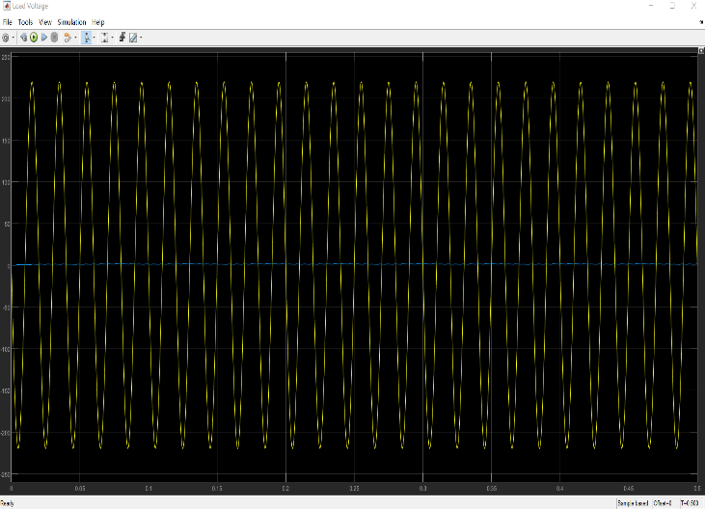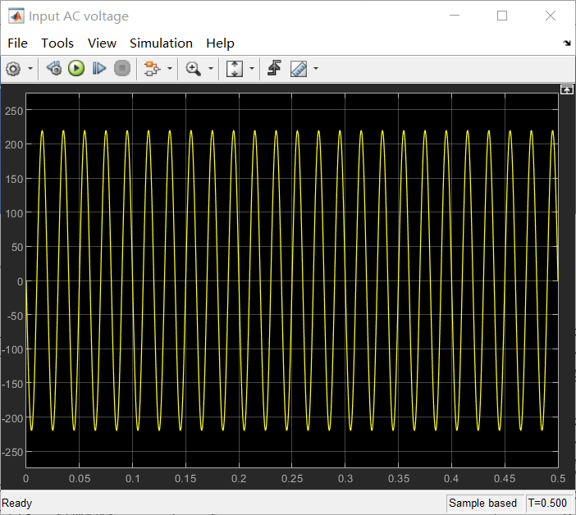

**Figure 42. CO2 System – Voltage measured over the load**

**Figure 41. CO2 System – Input AC voltage waveform**

### Energy Efficiency

**Figure 43. CO2 System – Efficiency of the CO2 system**

An open-loop control system used to control the level of the concentration of CO2, which takes input under the consideration and doesn’t react on the feedback to obtain the output.

# façade/Roof Subsystem

## Qualitative Description:

## The façade/roof subsystem is used to drive a load, which is a moveable façade, that adjusts the position of the panel solar. To achieve this was used solar panels to generate the energy needed to move the façade. Moreover, this energy is then converted to a dc motor and a closed-loop control system manages this conversion to avoid power losses and is also used a closed-loop control system to control the motor to make the load move.

## Quantitative Description: Specification Table

|  |  |
| --- | --- |
| **Component** | **Specification** |
| Solar Panels | 20 Kg mass which is an ac source |
| MOSFET rectifier | Composed by 4 MOSFETs |
| Capacitor | 1 capacitor to store energy |
| H-Bridge | Composed by 4 MOSFETs |
| Dc motor | Simple brushed dc motor to drive the load |

## Model: The Simulation model diagram(s)

### **Overall Model**

Figure 44 illustrates the overall subsystem.

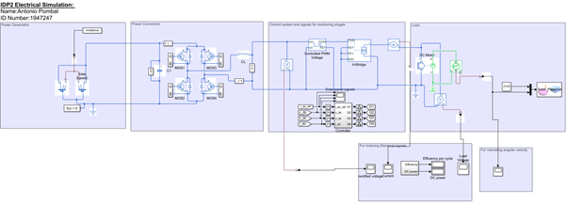

**Figure 44. Simulink Model of the Façade/ Roof Subsystem**

### 

### **Power Generation**

This subsystem uses solar power for electric generation. Therefore, it uses solar panels to generate ac power. This electric power is then transmitted to the conversion subsystem.

### 

**Figure 45. Façade/Roof Subsystem Power Generation**

### **Power Conversion**

### The energy generated from the solar panels is AC. Therefore, Figure 46 is composed of a MOSFET rectifier composed of 4 MOSFETs that are controlled by the control subsystem, to rectify the voltage avoiding electrical losses.

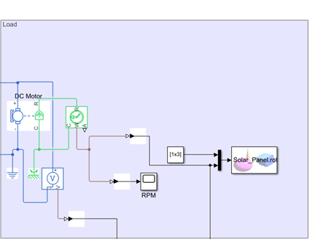

**Figure 46. Façade/Roof Subsystem Power Conversion**

### **Load**

### After rectification, the energy is transmitted to the load and to the control system. The load is composed of a DC motor and a mechanical domain. Figure 47 shows the load subsystem and can be seen that the DC motor converts the electrical energy to mechanical energy and the angular displacement can be seen in the block Sink VR (Solar panel) in the Matlab.

**Figure 47. Façade/Roof Subsystem Load**

### **Control**

Figure 48 shows the control subsystem used to control the overall subsystem, these subsystem control directly the load, and the power conversion. Therefore, it controls the speed of the motor, the position of the load and the on/off state of the MOSFETs used to generate electrical energy all these better harness energies and avoid power losses.

**Figure 48. Façade/Roof Subsystem Control**

Analysis: The Simulation Result

## Inputs and Outputs

The system generates energy from the solar panel. Furthermore, after that, it converts this power to DC power. Figure 49 shows the power generation and rectification.

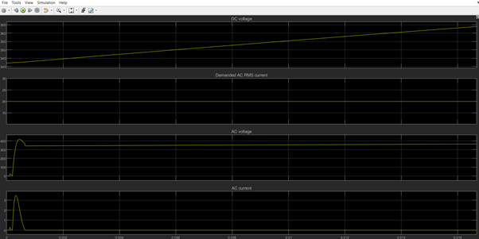

**Figure 49. Input Voltage and Current**

Figure 50 shows the voltage rectification and therefore the voltage input to the DC motor.

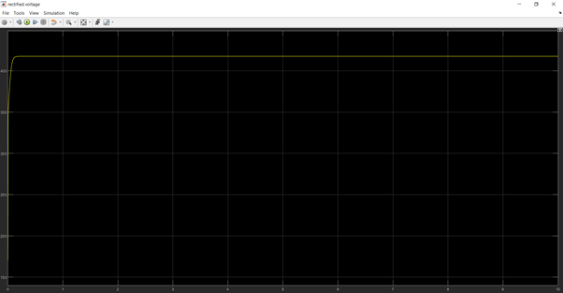

**Figure 50. Rectified Voltage**

Figure 51 shows the motor angular velocity of the motor that drives the load.

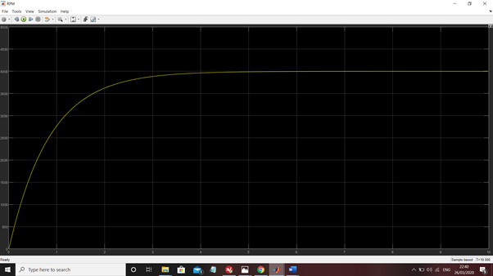

**Figure 51. Motor’s Angular Velocity (Output)**

Figures 52 and 53 shows the simulation of the movement of the solar panels driven by the motor.

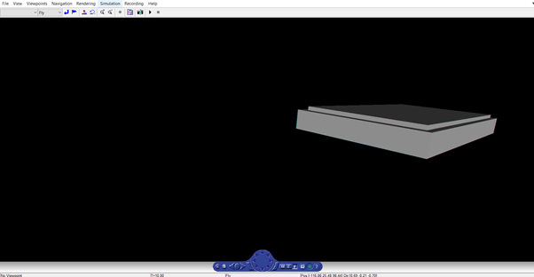

**Figure 52. Solar Panel Position 1**

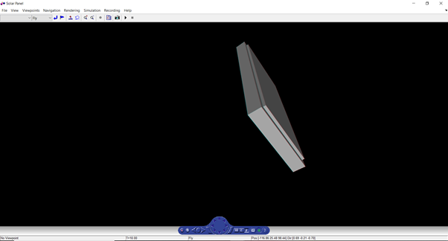

**Figure 53. Solar Panel Position 2**

### **Energy Efficiency**

### The facade/roof subsystem will have power losses from the moment of its generation to the load. Furthermore, the subsystem does not need any gain because solar energy is enough to drive the load of roughly 20 kg. Moreover, thanks to using MOSFETs instead of diodes for the rectifier making the subsystem more efficient. The control system used calculates energy efficiency as can be seen in figure 53.

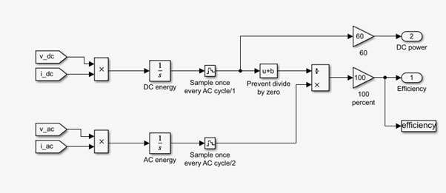

**Figure 53. Efficiency calculation**

In addition to this all control systems used were closed-loop helping for less power losses.

# Waste Subsystem

<this section carries 10% of the final report mark>

## Qualitative Description:

< A qualitative description which includes a coherent description which incorporates any enhancement positions you have reached as outlined in the EE handbook e.g. mechanical load requirements and visualisations, enhanced source characteristics and/or control and industrial applications. – 100 words max – 15% of marks for this report section >

## Quantitative Description: Specification Table

< A table with key data one would expect if looking at a datasheet. This may include: Packaging: Structure, Dimensions and Mass; Interfaces: Power Input, Power Output and any control/PEBB industry standard interfaces (optional); Qualification Environments: Thermal/Operating temperature, mechanical (optional) and EMC/ESD (optional); Production: Capacity and schedule; Reliability (in fits). – 100 words max – 15% of marks for this report section>

## Model: The Simulation model diagram(s)

< The electrical model should compile, and the notation should be correct with meaningful names given to components. Any enhancement positions you have reached should be clear e.g. the model may incorporate other physical domains including mechanical and thermal domains, and Simulink domain for control – 35% of marks for this report section>

### Overall Model

<a diagram of the overall model – details should be in specific areas and or blocks as described below. An example model from lab 5 which could be used as your template is here:

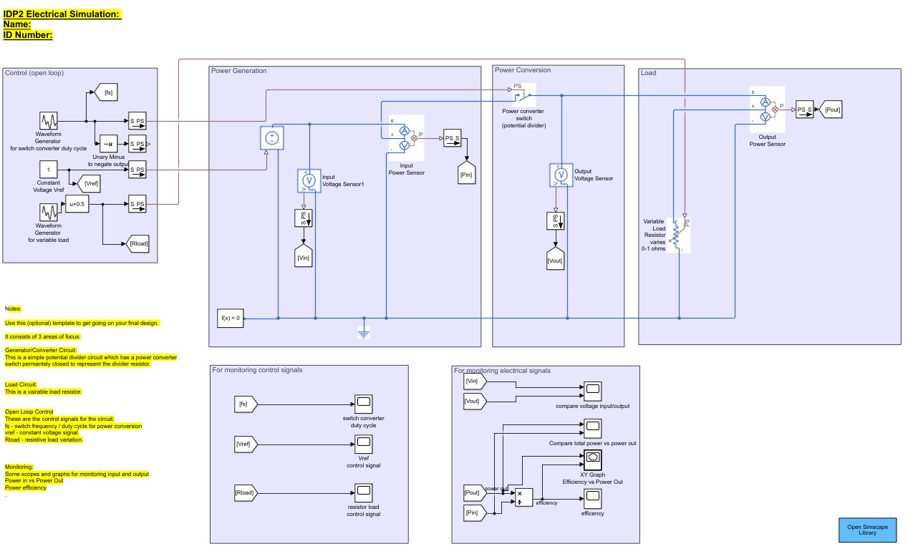>

### Power Generation

<your power generation model – screenshot(s) of the areas/expanded blocks of the Simscape diagram corresponding to power source/generation. Describe how it is enhanced from the basic DC voltage-controlled source in the template– 100 words max. >

### Power Conversion

<your power converter model – screenshot(s) of the areas areas/expanded blocks of the Simscape diagram corresponding to power conversion. Describe how it is enhanced from the basic potential divider provided by a permanently closed switch given in the template– 100 words max >

### Load

<your load model – screenshot(s) of the areas of the Simscape diagram corresponding to load. Describe how it is enhanced from the basic electrical domain-only variable resistor given in the template– 100 words max >

### Control

<your control model – screenshot(s) of the areas of the Simscape diagram corresponding to control. Describe how it is enhanced from the basic open-loop control in the template which supplies a duty cycle, reference voltage, and varies the load given in the template– 100 words max >

## Analysis: The Simulation Result

<These should be graphs conveying source/load and efficiency/loss characteristics following those given in the template. In addition to electrical inputs and outputs, those from other domains such as mechanical and thermal can be included as applicable.- 35% of marks for this section >

### Inputs and Outputs

<provide an analysis of your electrical circuit behaviour with reference to voltage, current, power and other signals. This may include other domains you have chosen to model e.g. mechanical for the load. – 100 words max>

### Energy Efficiency

<explain your energy efficiency (Pout/Pin) in terms of its variation against different load conditions using the template efficiency scope and xy graph as a starting point. In your results analysis you should refer to causes of efficiency losses due to your choice of non-idealised components, and correspondingly any efficiency gains due to your circuit design e.g. your component and component-value selection, and open or closed-loop control scheme. – 100 words max >

# AppendiCES

## APPENDIX A: Meeting Log

|  |  |  |
| --- | --- | --- |
| **Date** | **Agreed Actions** | **Attendees** |
| 29/01/2020 | Everyone has selected a section for the farm. | All |
| 29/01/2020 (data marked wrongly) | The VR model is agreed for our task 1. Deciding what software to use. | All |
| 03/02/2020 | Subsystem Research | All |
| 17/02/2020 | Simulink Model Ideas, VR progression/ ideas | All |
| 24/02/2020 | Sharing Simulink Models and finalize which power generation to use. Finalizing VR model. | All |
|  |  |  |

## APPENDIX B: ACADEMIC MENTOR MEETING FORMS

William

James, Callum, Simon, Tao, Renato

## 

## 

James, Callum

William, Renato, Simon, Tao

## APPENDIX C: Covid-19

The Covid-19 virus has impacted this group project in the following ways:

* Group members have returned home making collaboration in this project more difficult, especially as members of this groups live in different continents.
* Equipment located at the university couldn’t be used (computers and VR equipment).

## APPENDIX D: VR MODEL SCREENSHOTS

